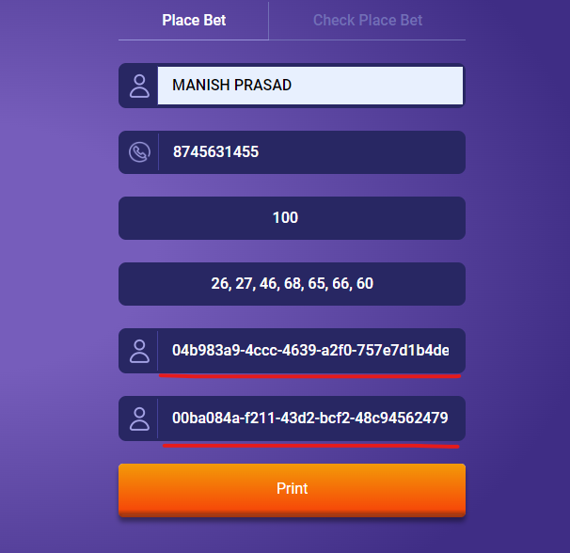

Add Text Bet ID and uest ID

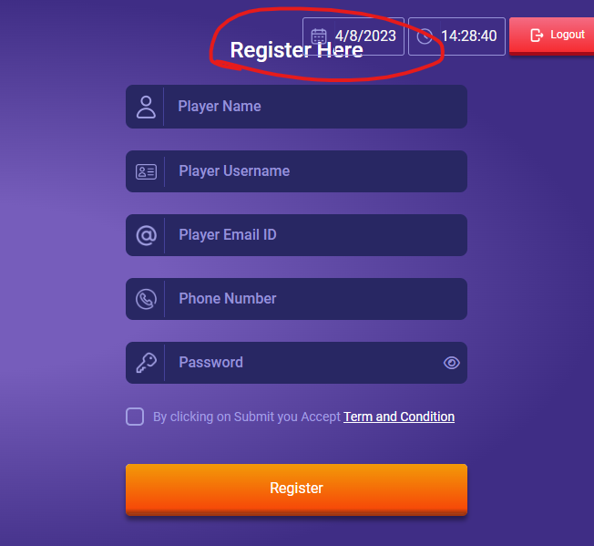

Fix Alignment

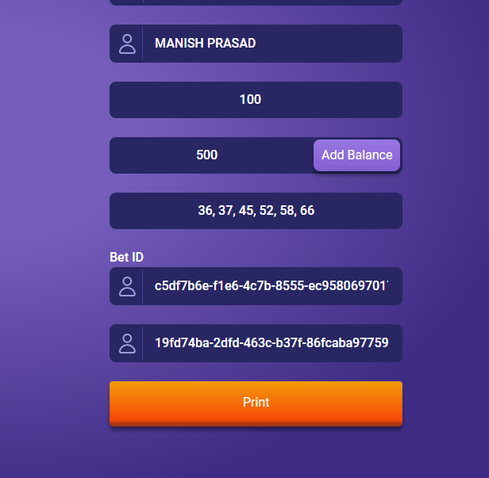

Add Guest ID Text

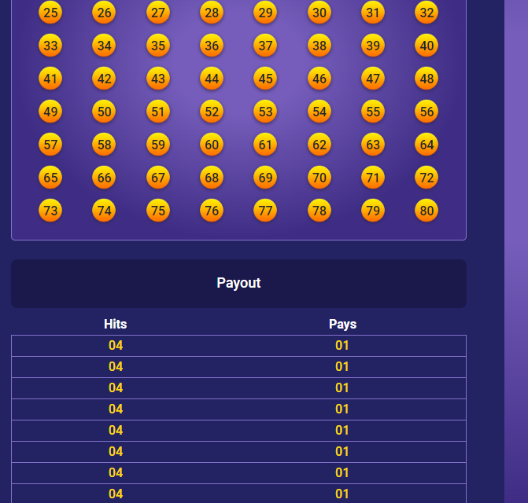

Make the below payout adjusted as per the nos selected as per the payout table

--Please make the payment tab disabled for the currents as there is works going on the transaction module

--- On the Cashier Login - Restrictions required, if the User type is nt slected error messae -” Please Select a User Type”

--- If the user and his credentials are mismatched, please show a error messae “User Type and User Credentials Not Matchin. Please Try Aain”

--- Please remove the Player from the User type dropdown

PLayer Login

- When player logs in successfully, the player should get redirected to the gameplay screen

Admin Panel ---

--- In the Players Menu, Please add deposit option