# Recruitment

Please follow the below steps to use the **Recruitment** Module in the **EMS** portal.

Note: if you are not able to see the **“Recruitment”** menu, please login again. If you are still not able to see the menu, please contact **EMS** support team.

1. Once logged in, you can access the **“Recruitment”** menu from the left panel of the **EMS Portal**. Please see the red highlighted section for your reference.

Job page-

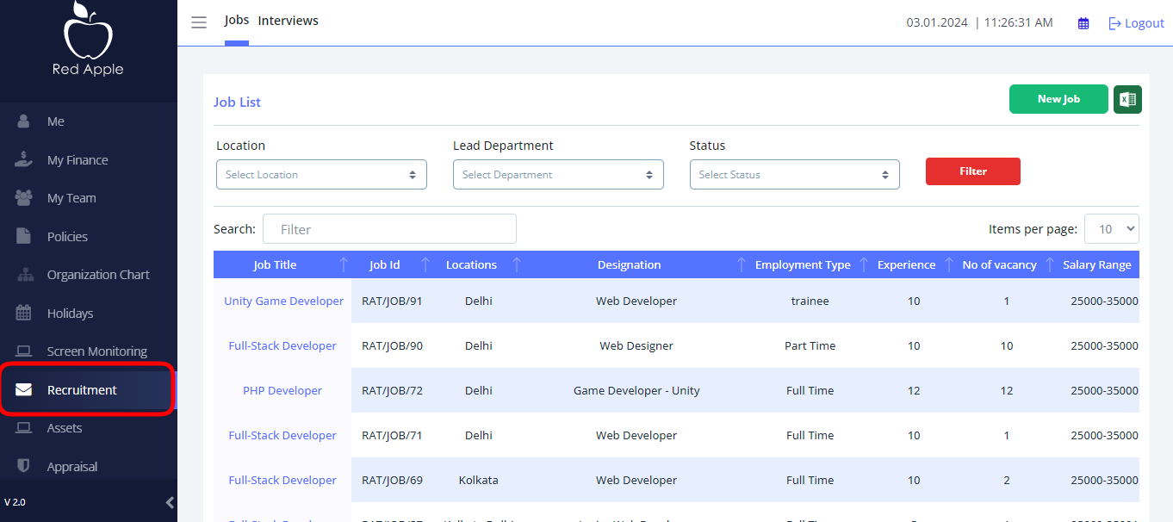

1. **Recruitment** module can be filtered by their status.

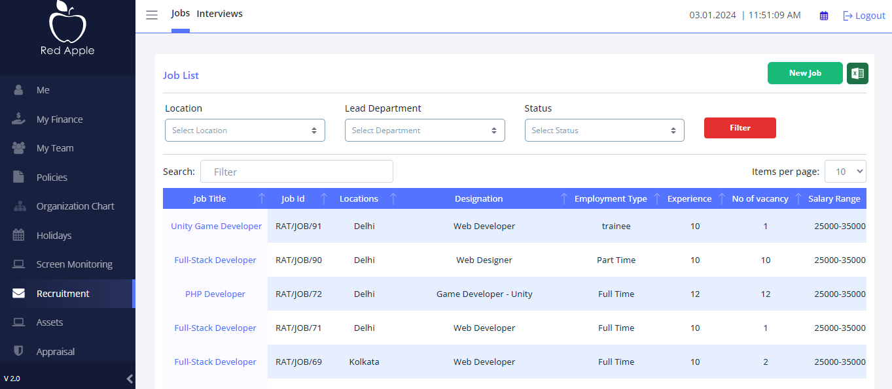

1. Clicking on a Job title will take you to the **Job details** page. The details page consists of several tabs. Each tab represents a specific sub module of a Job. The first tabs “job details” shows the overall status of the Job.There you can seen **edit** , **delete** and **Candidate** option.

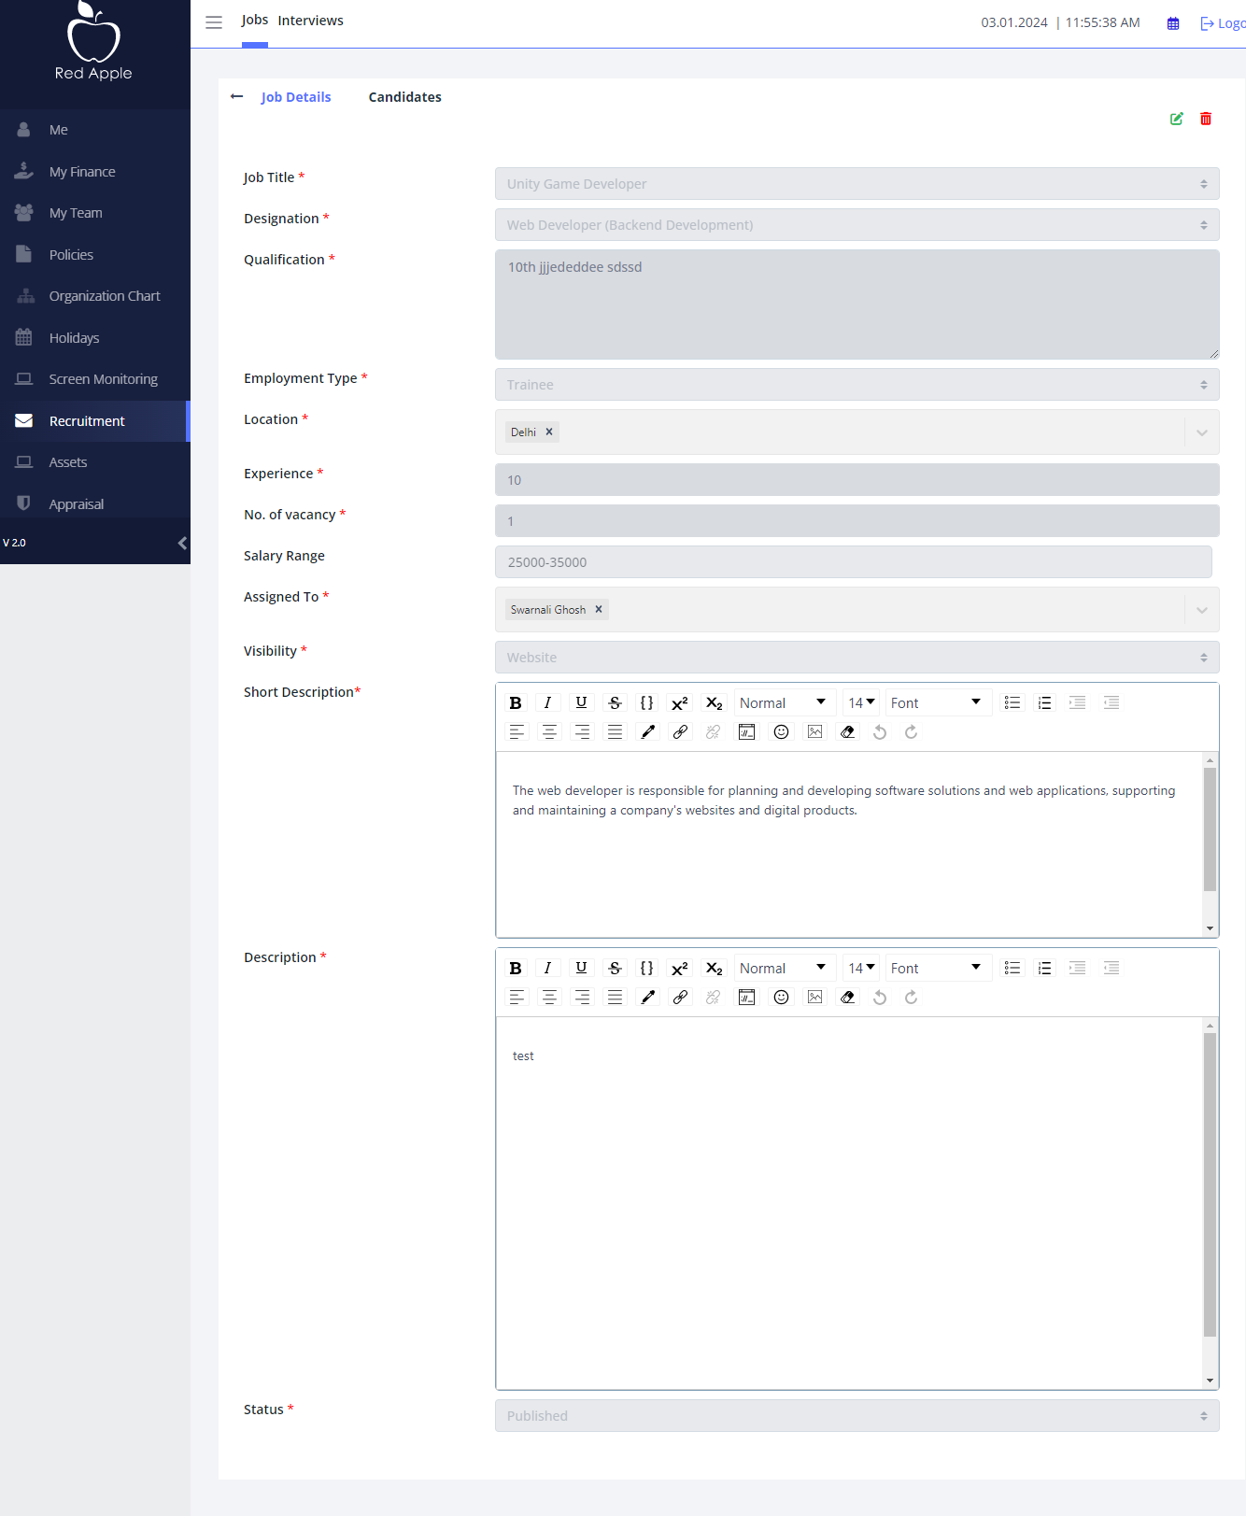

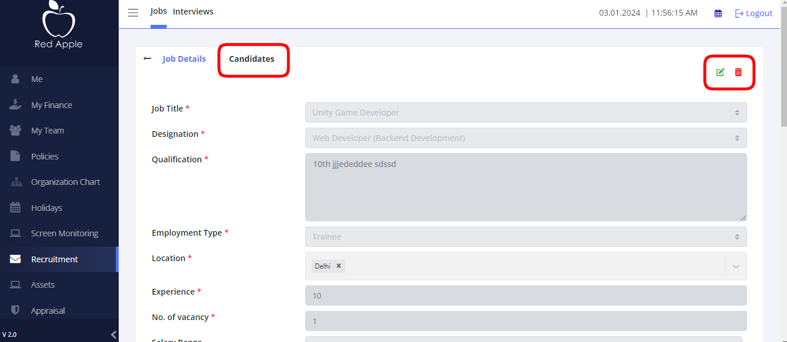

Beside **Job details** you see **Candidates** option,there you can see **Candidate list** and also add **Candidates** by clicking **New** **Candidate .** Clicking on **Candidate** title will take you to the **Candidate details** page. The details page consists of several tabs. Each tab represents a specific sub module of a **Candidates.**

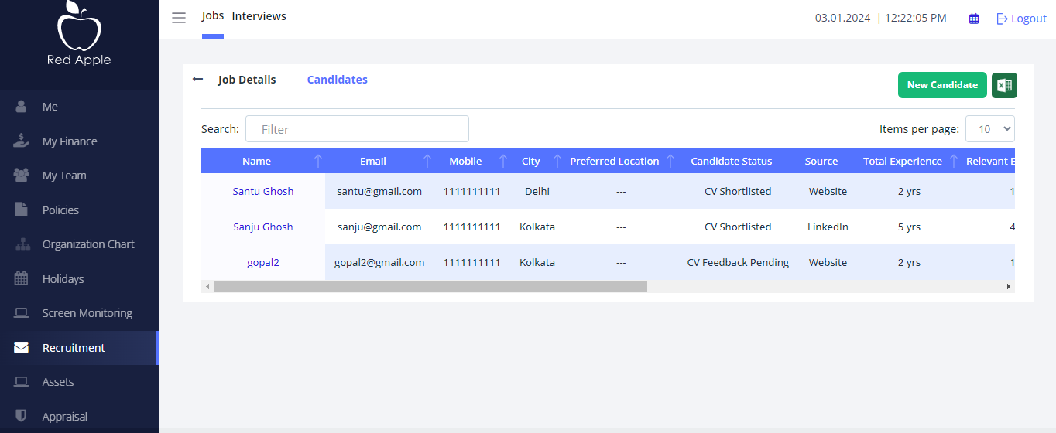

And **add** new candidate by just clicking **“new candidate”**.The details page consists of several tabs. Each tab represents a specific sub module of candidate. There also you add **resume** and **cover page** of the candidate.and then save.

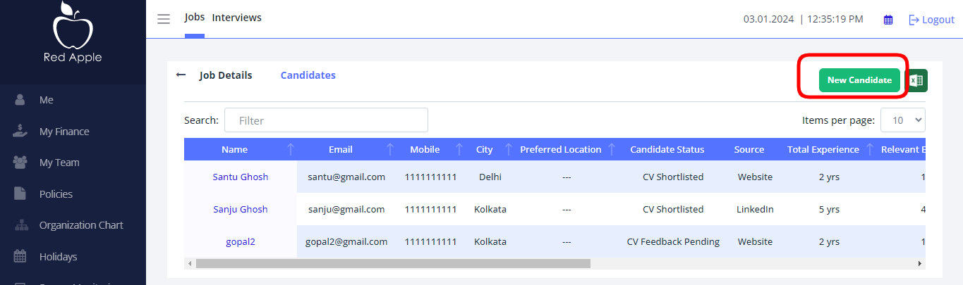

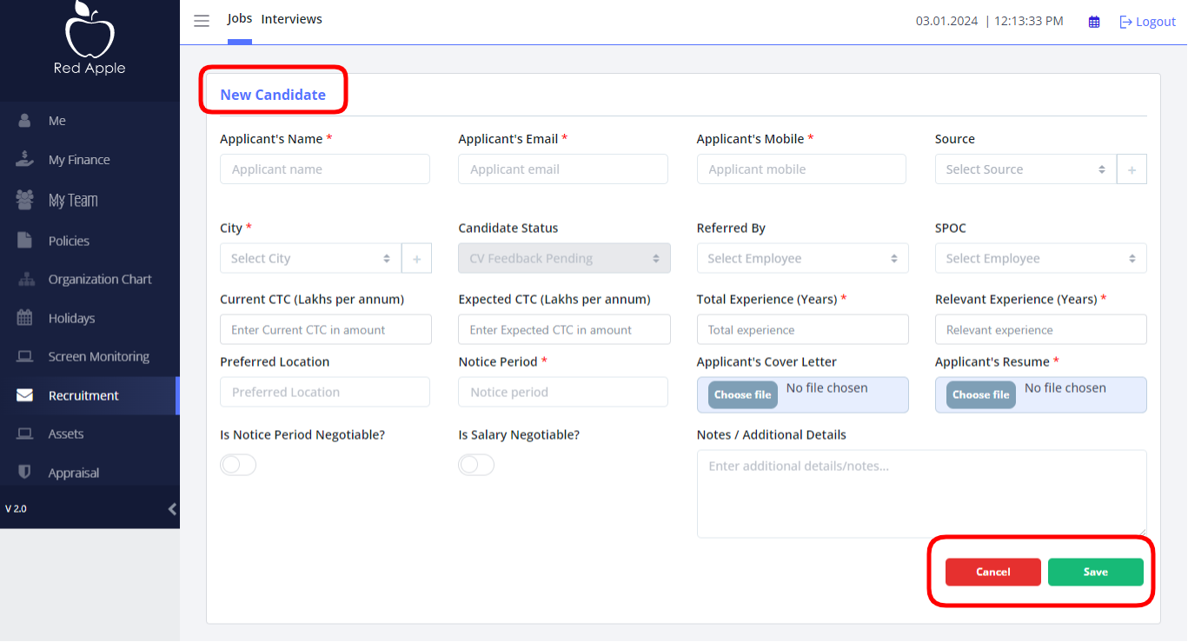

By clicking any candidates name will take you **Candidate details** page there you can see **Candidate details** and also see resume ,edit or delete the profile,, schedule any interview and even see previous Interview details and the status.

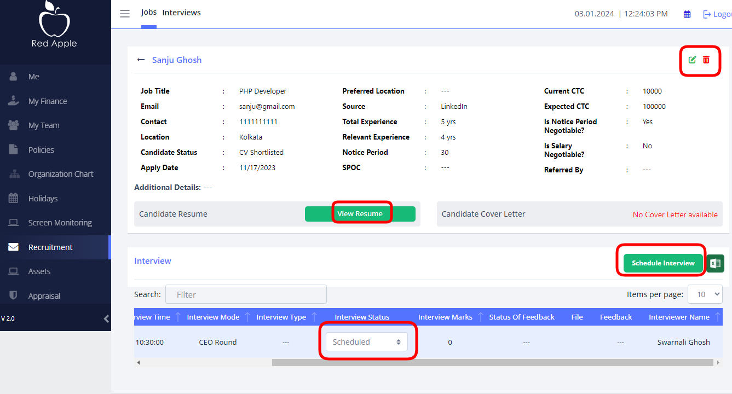

Now you click **INTERVIEW** option. There you can see details of all **“INTERVIEW LIST” and Candidates** details ,current status. You can also add **Feedback** by clicking **“Add Feedback**”.



