Regular steps (new member or to login)

Open App, (slide one)
Choose Login or Sign up (slide two)

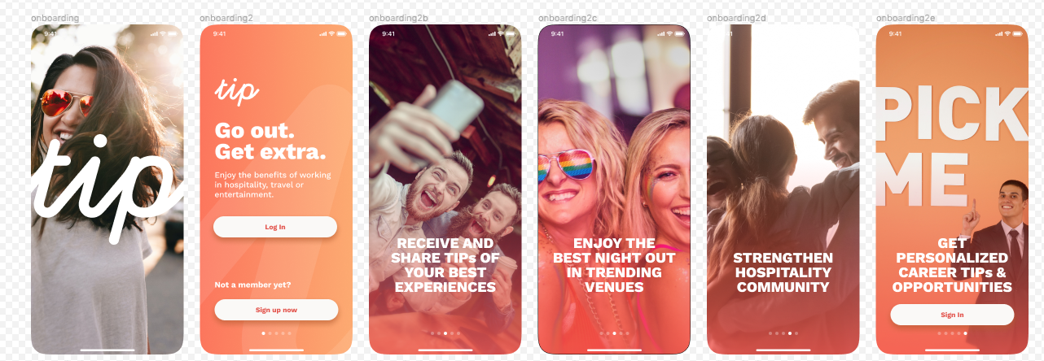

Choosing Log in keep current steps in place
Choose Sign up

New slides for In-App registration come into place.
Verifying tel or Email (as current).

After verification code is entered, Your Profile + Your Company info is requested.

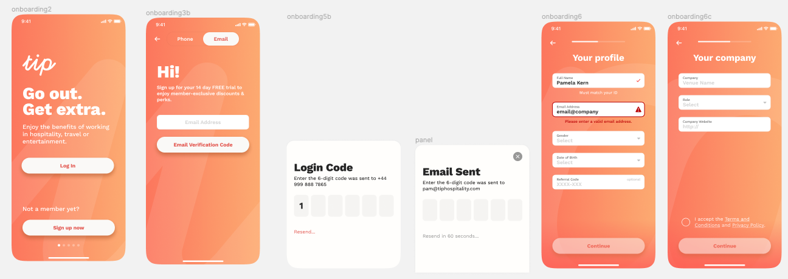

Followed with: Your profile is being verified.

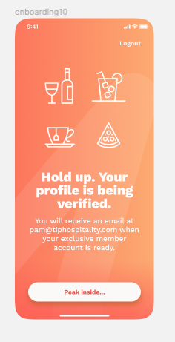

Can we then have this step to directly to be automatically verified, with the verification email send and they have access to the TIP app.

Then after the 14 days trial, the member still has access to the app, but the moment they want to make a booking (by using the Book Now or Check In button in the app) the will be prompted this pop-up screen

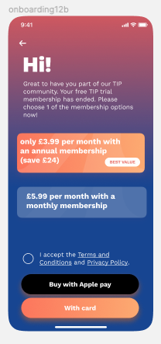

They choose the membership option 1 or 2 and choose the option to pay with Apple Pay, or with credit card..

The card payment we need to discuss how the next slide would look like.

